Lab program Number: 9 Date: 2082-05-01

Title: Basic router configuration and static routing in Packet Tracer

**Theory**

**Router**

A router is a network device that forwards data packets between computer networks. Routers perform traffic directing functions on the Internet. A packet is typically forwarded from one router to another through the networks that constitute the internetwork until it reaches its destination node.

**Network Diagram**

Fig: Network diagram including router and switch

**Implementation Sequence**

Here is the implementation sequence for Basic router configuration and static routing in Packet Tracer.

**Basic router Configuration**

**Configuring Global Parameters**

Here are the steps to configure global parameters on a router:

**Step 1: Open Packet Tracer and set up the devices (routers, PCs).**

Fig: Simple Network setup

**Step 2: Access the Router CLI**

Use the console cable to access the router’s command-line interface (CLI)

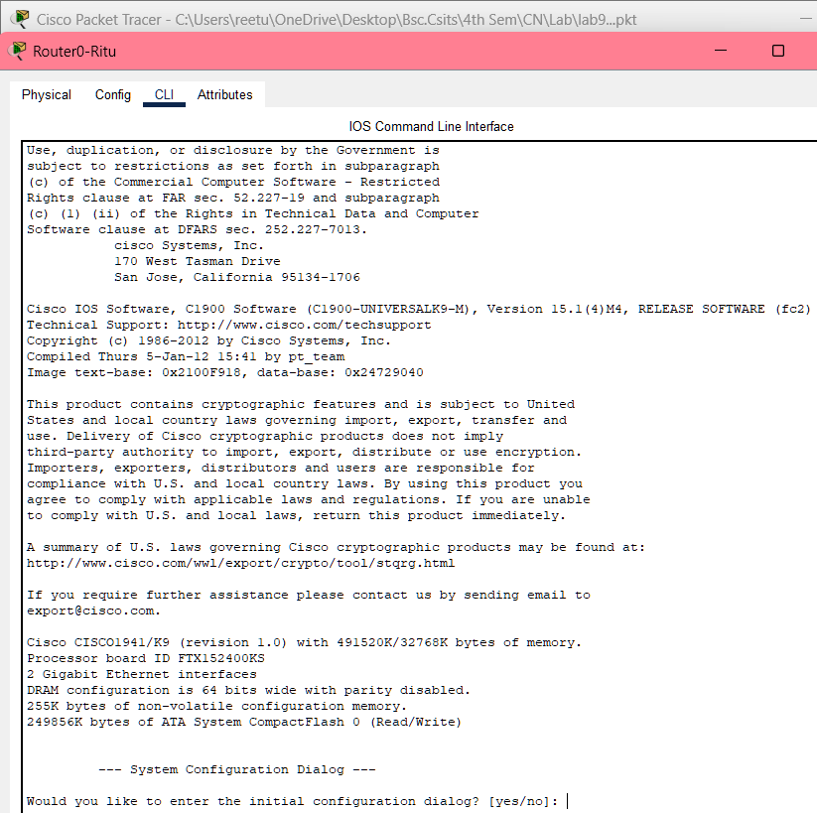

Fig: Accessing Router Command-Line Interface via Console Cable

**Step 3: Configure Terminal**

Type enable to enter privileged EXEC mode and use configure terminal to access global configuration mode.

Fig: Entering Privileged EXEC and Global Configuration Mode on the Router

**Step 4: Set a hostname for the router**

Use the command hostname [RouterName] to assign a name to the router.

Fig: Setting the Hostname on the Router

**Step 5: Configure a Password for Privileged Mode**

Set an enable password using Router(config)#enable secret [password]

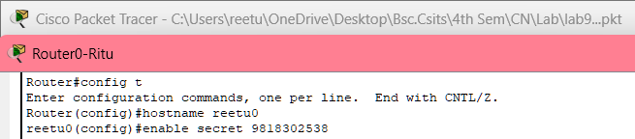

Fig: Configuring a Password

**Configuring Gigabit Ethernet**

Here are the steps to configure gigabit Ethernet interfaces on a router:

**Step 1: Configure Terminal**

Type enable to enter privileged EXEC mode and use configure terminal to access global configuration mode.

Fig: Entering Privileged EXEC and Global Configuration Mode on Router

**Step 2: Access the interface configuration mode**

Use the command interface <interface_name> to enter the configuration mode for a specific router interface.

Fig: Accessing the interface configuration mode

**Step 3: Assign an IP address**

Once in the interface configuration mode, assign a unique IP address and subnet mask to the interface using the Ip address command.

Fig: Enabling the Gigabit Ethernet Interface on Router

**Step 4: Enable the interface**

After assigning an IP address, use the no shutdown command to activate the interface.

By default, router interfaces are in a “shutdown” state.

Fig: Enabling the Gigabit Ethernet Interface on a Router

**Static Routing Configuration**

**Configuring Network (PCs and Routers)**

**Network Diagram**

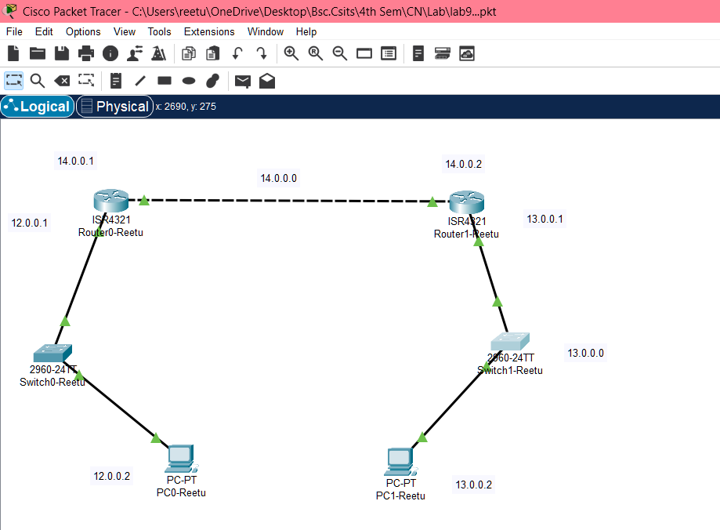

fig: Network Diagram for static routing

**Configuring PCs**

**Step 1: Assign IP addresses to the PC’s**

Configure the IP addresses on the PCs within the same network as their respective router’s interface.

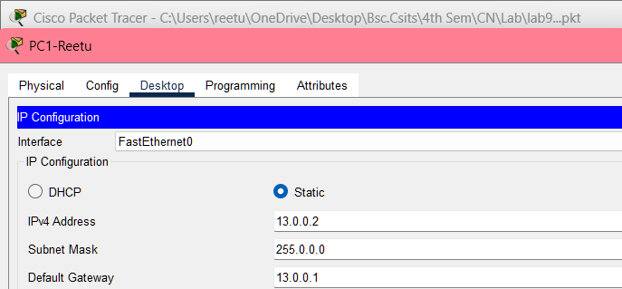

Fig: Assigning IP address to PC’s

**Configuring Routers**

**Step 1: Set the IP address on the Gigabit Ethernet interface**

**For router0**

Fig: Configuring IP Address on Gigabit Ethernet Interface

**For router1**

Fig: Configuring IP Address on Gigabit Ethernet Interface

**Step 2: Checking Router is working or not**

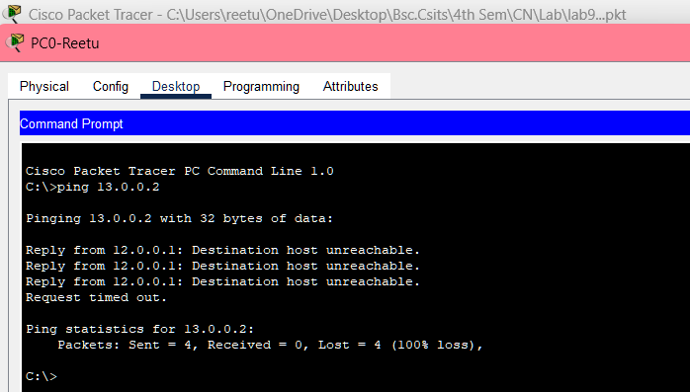

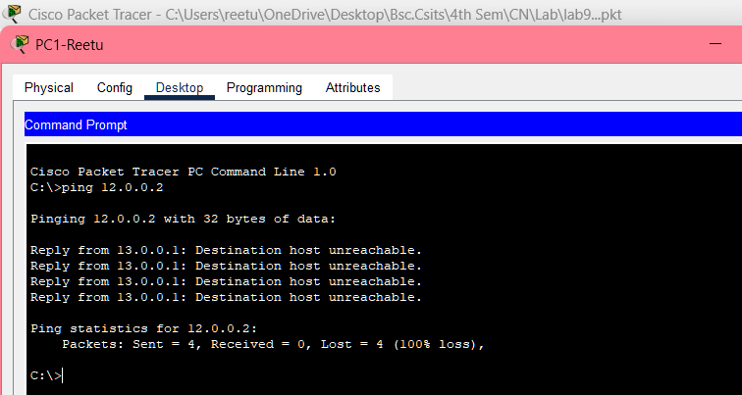

Fig: Router Connectivity Test Failure

Above figure shows two failed ping attempts from different PCs to check connectivity. Both PCs are trying to reach different IPs (13.0.0.2 and 12.0.0.2), but the destination hosts are unreachable. The error message 100% packet loss indicates a problem with the router’s configuration or connection between networks. This suggests that the router is not routing packets correctly between these networks.

**Step 3: Adding a static route**

Adding a static route to Router R1’s network

Fig: Adding Static Route to Router 1 Network

Add a static route to Router R0’s network

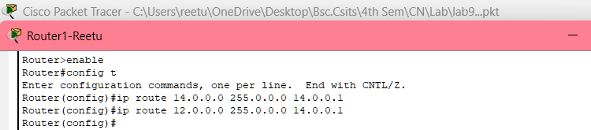

Fig: Adding Static Route to Router R0 Network

**Testing and Validation**

From each PC, use the ping command to test connectivity to a PC in a different network.

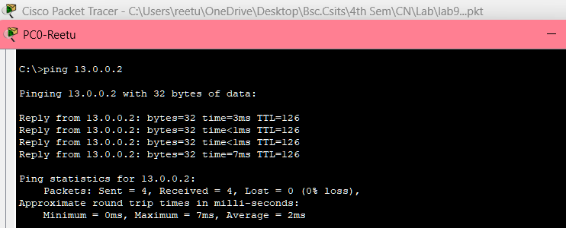

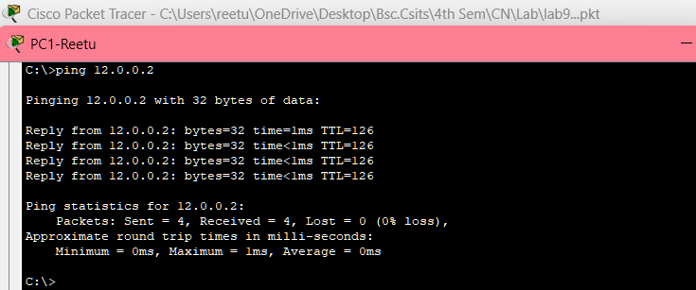

Fig: Testing Connectivity Between PC’s Using Ping Commands

The above shows successful ping tests between two PCs in different networks. PC0 pings 13.0.0.2 with no packet loss and low latency, while PC1 pings 12.0.0.2 with similar successful results. This confirms network connectivity between the PCs.

**Addressing Table:**

The addressing table of the static routing is as follows:

|  |  |  |  |  |
| --- | --- | --- | --- | --- |
| Device | Interface | IPV4 Address | Subnet | Default Gateway |
| PC0 | NIC | 12.0.0.2 | 255.0.0.0 | 12.0.0.1 |
| PC1 | NIC | 13.0.0.2 | 255.0.0.0 | 13.0.0.1 |

**Conclusion**

This lab introduced basic router configuration and static routing using Cisco Packet Tracer. We successfully set up routers and configured static routes, enabling communication between PCs on different networks. This exercise demonstrated essential network configuration skills and the importance of routing in ensuring connectivity.